Module 2

Anaconda Installation on Windows Machine

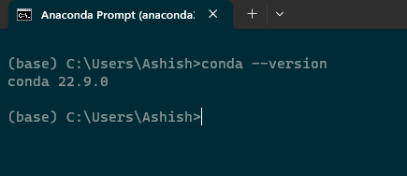

__✓__ I certify that I have installed Anaconda or similar python environment and have practiced python by following the Module 2 as shown below

**Variables and Objects**

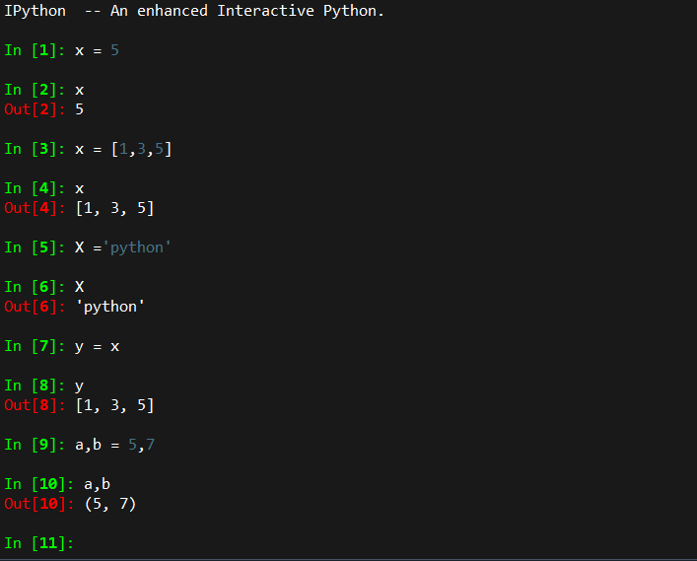

**Input and Output**

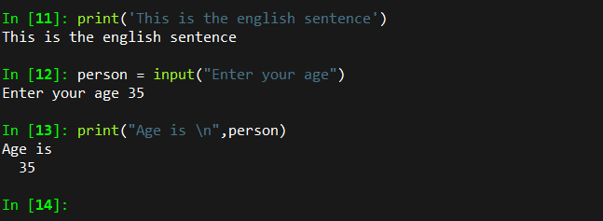

#### **Arithmetic and Complex Numbers**

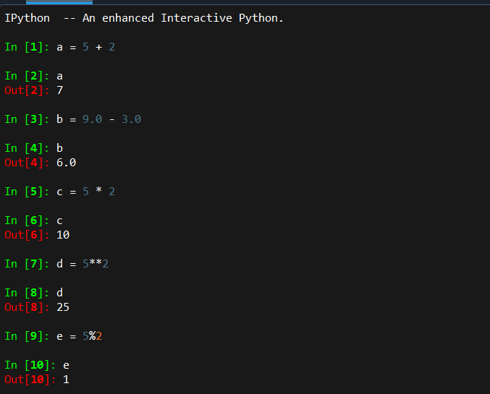

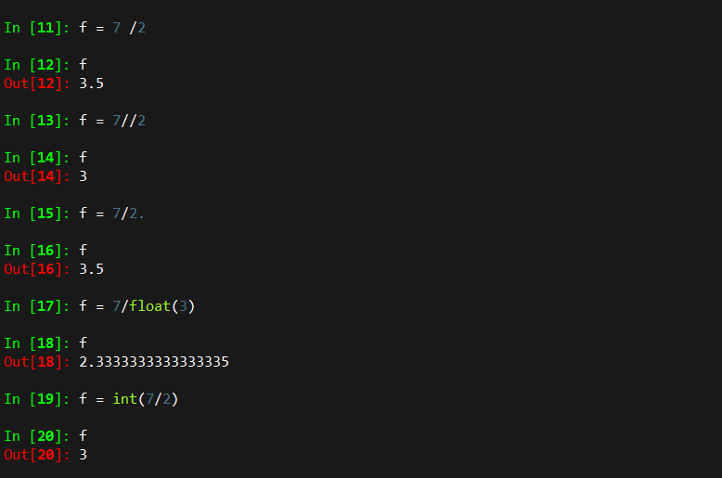

f = 1+2.56j

print(f.real,f.imag)

1. 2.56

#### **Strings**

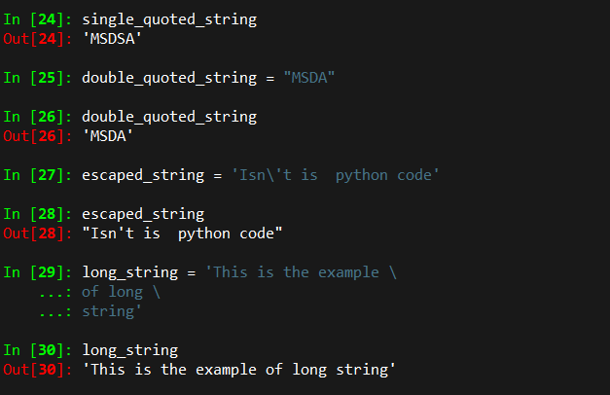

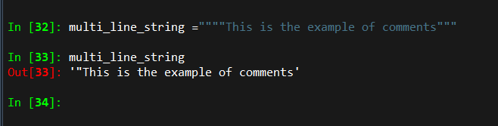

**String Concatenation**

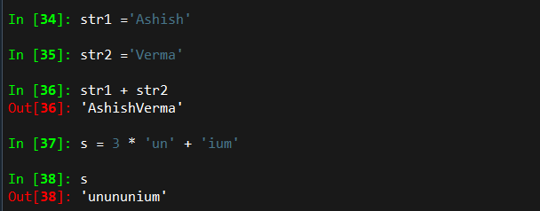

**Collection Data Types**

1. **List**: a collection which is ordered and *changeable*.  Allows duplicate members.
2. **Tuple**:a collection which is ordered and *unchageable*.  Allows duplicate members.
3. **Set**: a collection which is unordered and unindexed.  No duplicate members.
4. **Dictionary**: a collection which is unordered, changeable and indexed.  No duplicate members.

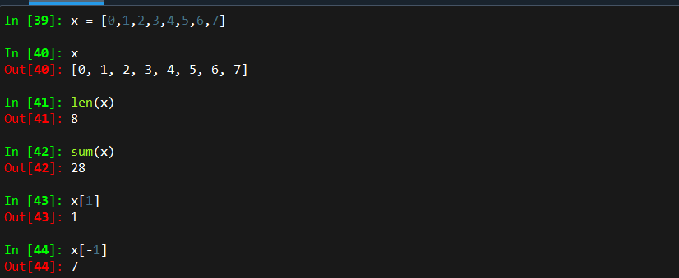

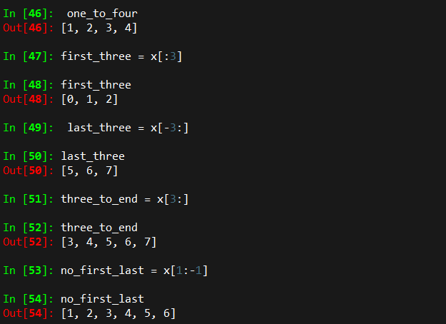

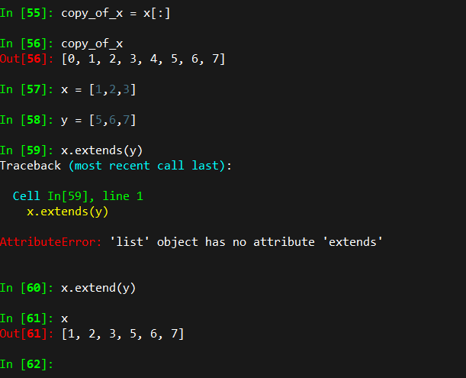

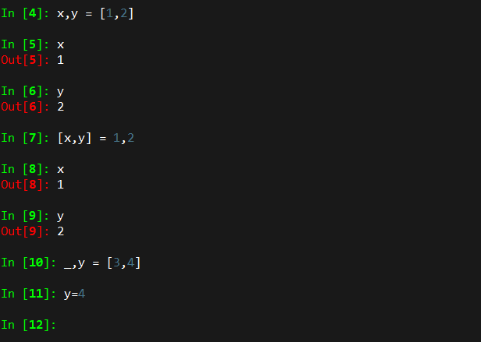

**Strings can also be sliced. But they cannot be modified (they are immutable).**

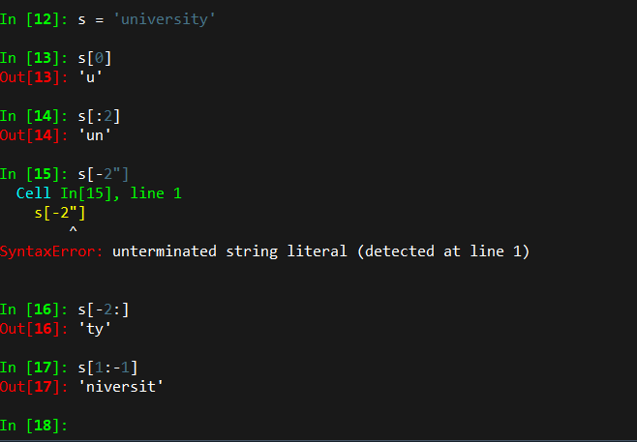

**Tuples--similar to lists, but immutable. Note:  tuple is defined by comma, not (), which is only used for convenience.  So a=(1) is not a tuple, but a = (1,) is.**

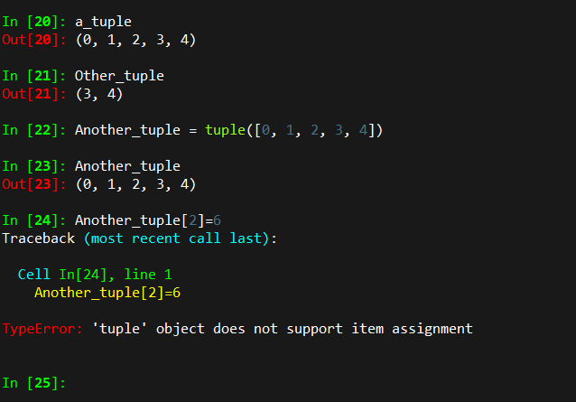

**Dictionaries**

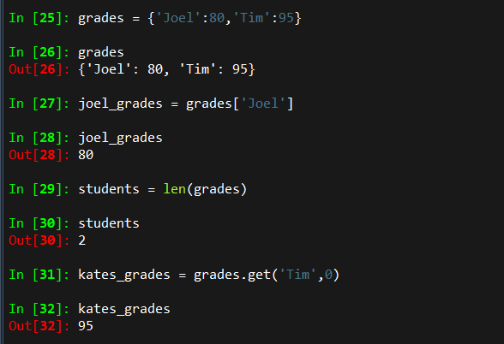

**Get all items**

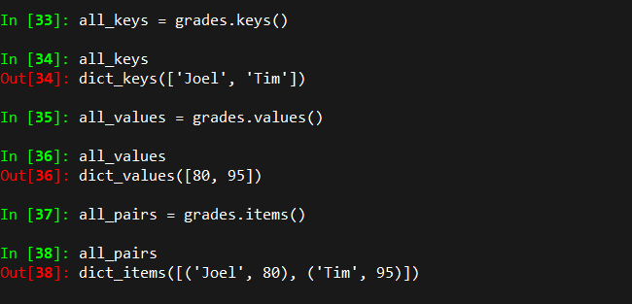

**Control Flow**

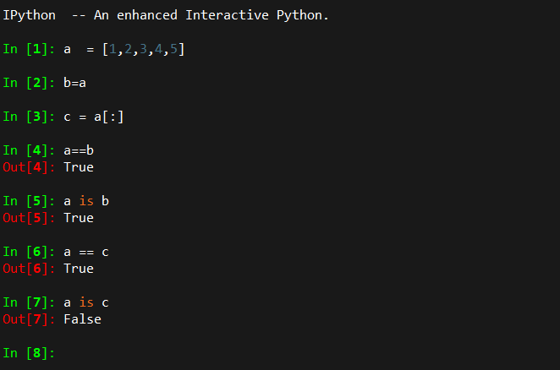

**Else If**

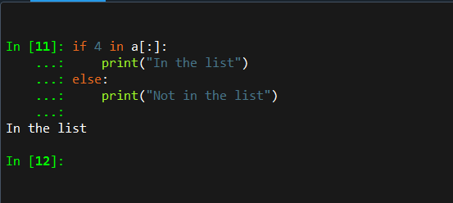

**Loops**

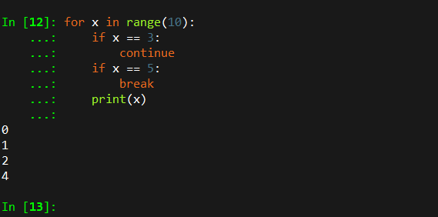

**Functions**

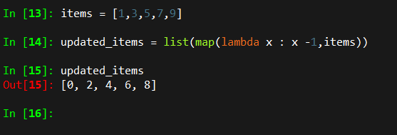

**Functions as Objects**

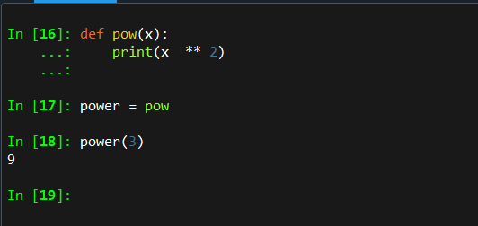

**Range Function**

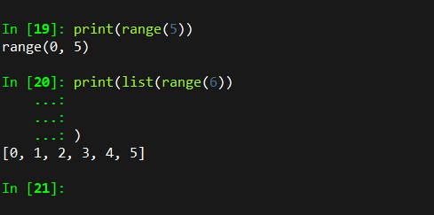

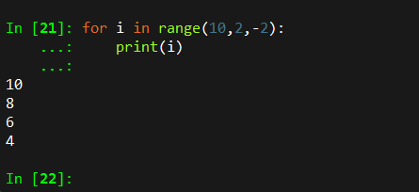

# Activity 1

The Company Naukha's new CEO's salary is $350,000. Use the following equation to generate the tax amount, where S=$300,001 is the Start of the income bracket, R=32% is the tax rate and A=$60,400 is the total tax amount owes from previous brackets.

tax = (income - S) * R + A

tax = (350,000 – 300,001) x 32% + 60,400 = $76,399.68

• Use the python multiple assignment to assign values for S, R and A.

• Write a simple function calculate_tax that takes the salary as the input and returns the calculated tax value.

def calc_tax(salary:int) -> float:

S,R,A = 300001,0.32,60400

tax = (salary - S) * R + A

return tax

calc_tax(350000)

Out[23]: 76399.68

### ****List comprehension****

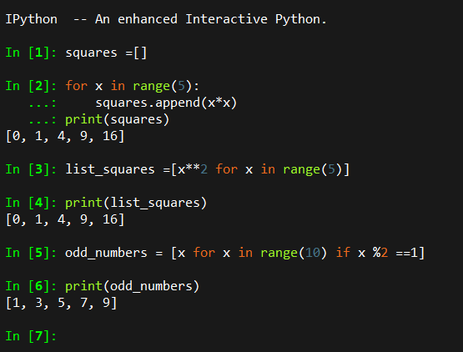

### ****High Order Functions****

**map(function_to_apply, list_of_inputs)**

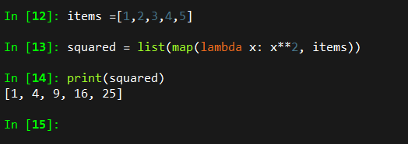

**The function reduce(func, seq) continually applies the function func() to the sequence seq. It returns a single value.**

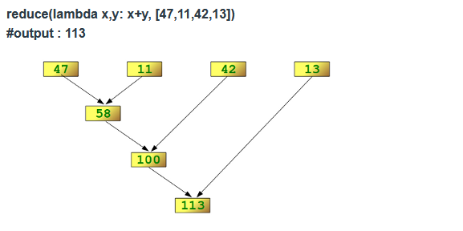

**Determining the maximum of a list of numerical values by using reduce and**

**Calculating the sum of the numbers from 1 to 100:**

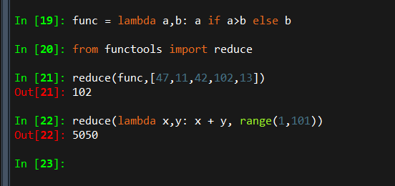

**Filter creates a list of elements for which a function returns true.**

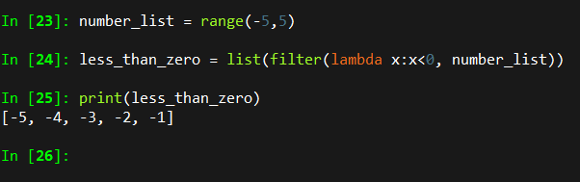

### ****Packing/Unpacking****

**ZIP:** Useful to combined multiple lists into a list of tuples

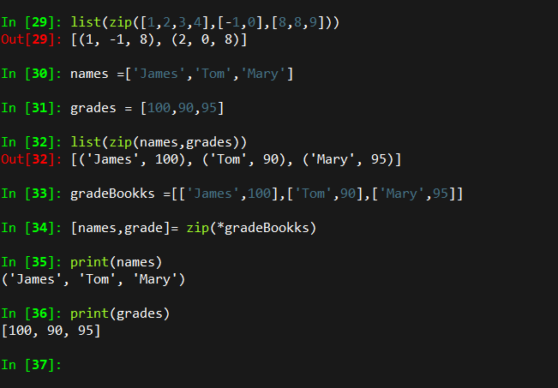

### **Module random**

### 